Trading on behalf

Members Procedure

BSP

Modification Logs:

Version | Date | Author | Comment
1.0 | 16/04/2024 | BSP | Creation
1.1 | 16/10/2024 | BSP | ETS 2 Decimals Submission

Remarks
All timings in the procedure are expressed as CET timings.

Summary

Objective of the procedure:

Describe actions to be taken by BSP member to submit orders in case of Trading on Behalf is needed.

Concerned persons:

BSP members on auction markets.

Historical of the document*

Historical of modifications**
Evolution | Date | Version | Comments
Creation | 16/04/2024 | 1.0 | Initial version
Update | 16/10/2024 | 1.1 | ETS 2 Decimals Submission

* (Update must be performed after any modification of the process)

** Current version must be designated with grey background

SUMMARY

1. Introduction 3
2. Business process 3
2.1 Download the excel forms from our website 3
2.2 Filling of the excel form 3
2.3 Correctness of the file 4
2.4 Fill-in the order table 4
2.5 Send your file via email and call Market Operations 5

Introduction

Dear member,

The Trade on Behalf (ToB) process aims to be a supporting tool when isolated issues occur disrupting your connection with the ETS system. In this case, you can download the excel forms from our website for the respective auction from this link: here.
This procedure is giving all the details and steps to be followed for ToB process.
(it can be found on our website here).

The ToB process is meant to be operated on a best effort basis.
Firstly, please send us via email your forms filled in, then call the Market Operations Department immediately. The goal is to be sure that your request will be treated with high priority.

This procedure is available only for SDAC Auction.

Business process

Below you will find the instructions on how to fill in the form and how to send it to Market Operations Team for validation.

The form has to be sent 15 min before the gate closure time at the latest. After that time, orders will only be accepted on a best effort basis.

BSP’s members must send us by email the form as soon as possible, in order to processed smoothly and on due time.

Download the excel forms from our website

Use only the file available on our website to request the ToB process.
Please be ensured to select the correct ETS Bidding Form file based on the type of order:
- Linear Order
- Block Order.
Please be careful to select the correct format:
- Normal Day => Select 1st Tab
- DST 25 => Select 2nd Tab
- The ones for the normal day should be used for Short Day DST without filing in the impacted periods.

Filling of the excel form

Once downloaded, fill-in the excel file with the below information:

- Trader Name: only authorized traders are allowed to send a ToB form and request its submission
- Portfolio to be used: Portfolio Name
- Action Type: New Order, Modification, Cancellation

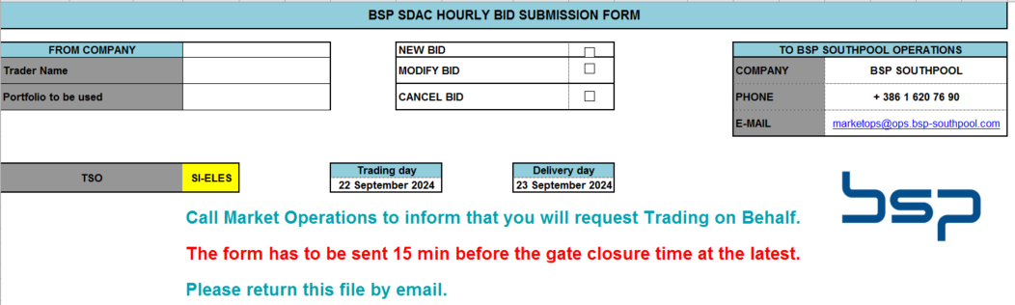

Correctness of the file

Ensure that the below information are correct:
- TSO: SI-ELES
- Trading Date
- Delivery Date

Fill-in the order table

Please ensure the table sent will reflect your bids.
Please add the prices and volumes carefully.

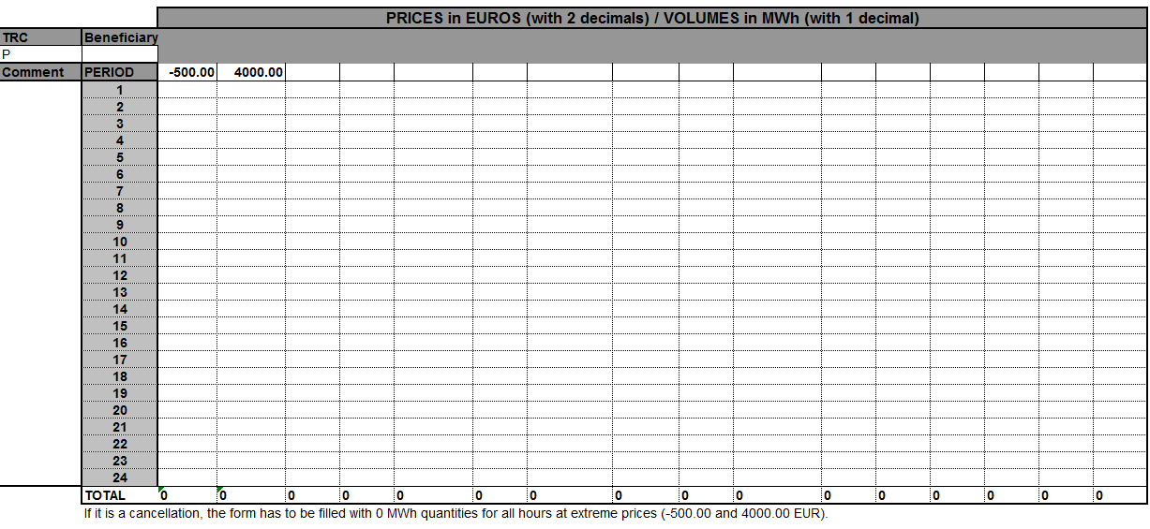

Send your file via email and call Market Operations

Send the file(s) via email to BSP Market Operations team and make sure to follow up by calling the Hotline below.

A crosscheck of you orders will be performed over the phone.

Please send the forms via email to: marketops@ops.bsp-southpool.com

and then call: + 386 1 620 76 90

BSP Market Operators will confirm bids have been integrated successfully into the Trading System.

A screenshot of your position will be sent by email.

The trader confirms the uploaded orders via email.

